**Docker- Petshop-Clinic**

**Prequisites:**

* yum install docker -y
* service docker start
* systemctl enable docker
* sevice docker status
* Download free html template from google , It is present in local download folder, we have to move this template from local downloads to amazon linux server.
* Website link : <https://www.free-css.com/template-categories/animals-or-pets>
* write Dockerfile
* vi Dockerfile
* Dockerfile:
* FROM httpd:latest
* MAINTAINER "Shrikanth C R"
* COPY ./Project-Petshop-Clinic/ /usr/local/apache2/htdocs/
* docker pull httpd
* docker build -t customized-image-name .
* command: docker build -t httpd
* docker tag source name destination name
* command: docker tag httpd shrikanthcr/httpd
* docker run -d -p 82:80 customized-image-name
* command: docker run -d –name httpd_container -p 82:80 httpd
* docker login
* username: shrikanthcr
* password: generate token in docker hub
* docker push customized-image-name
* command: docker push shrikanthcr/httpd

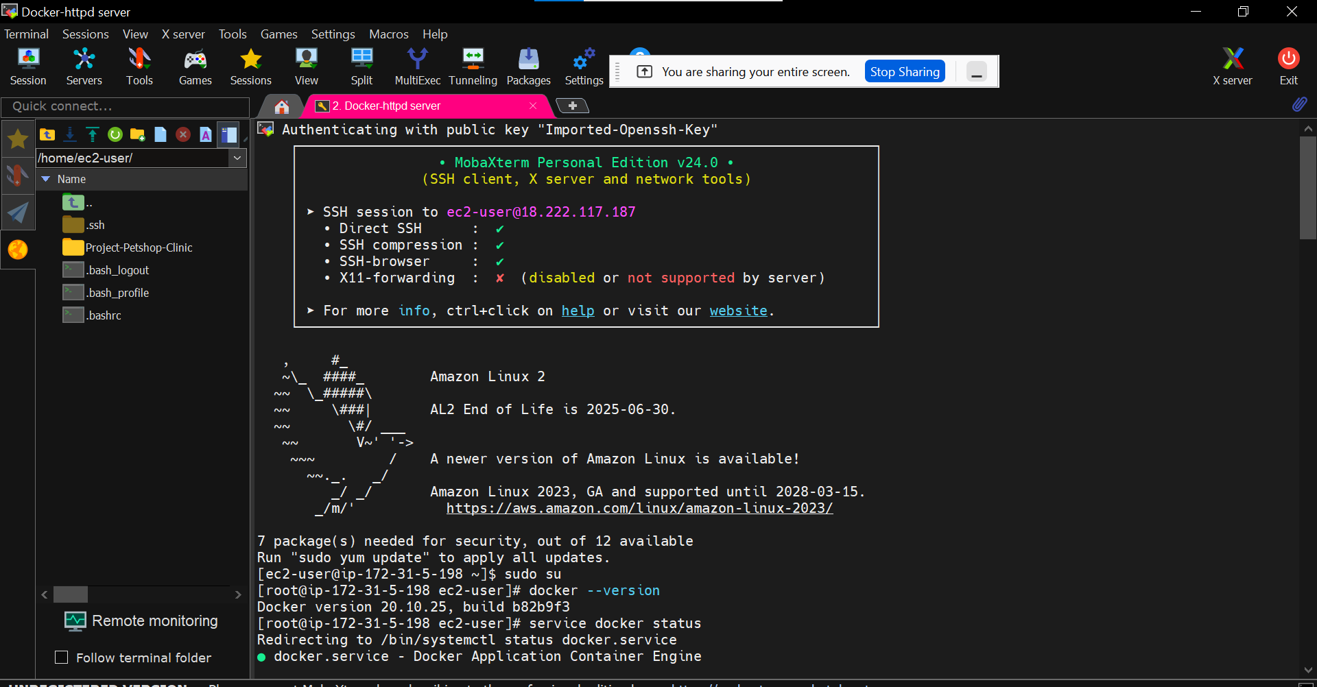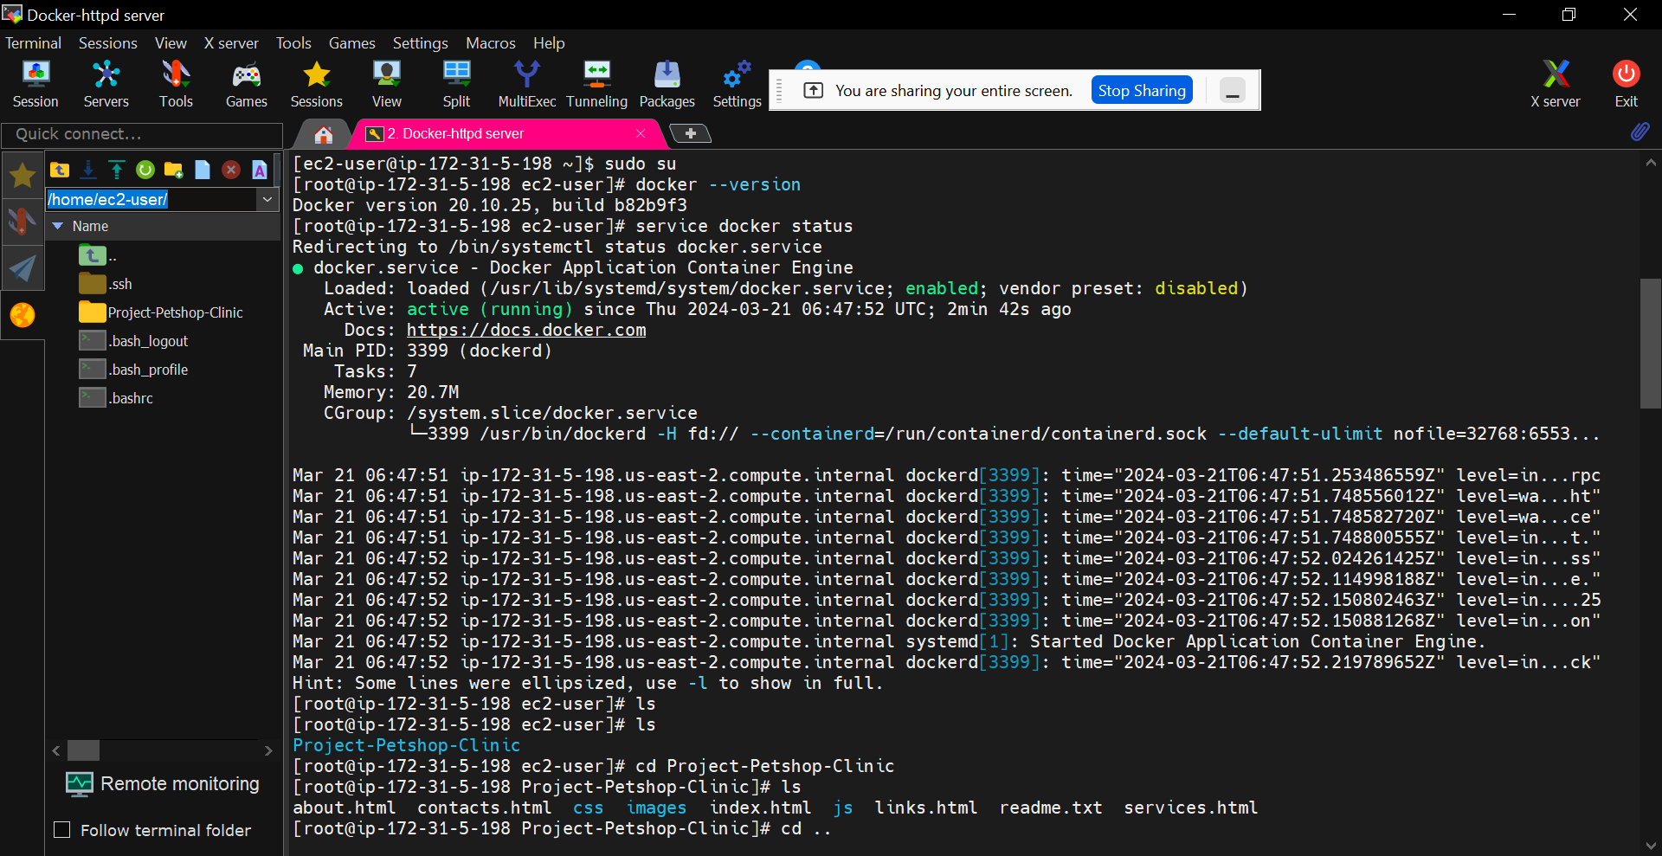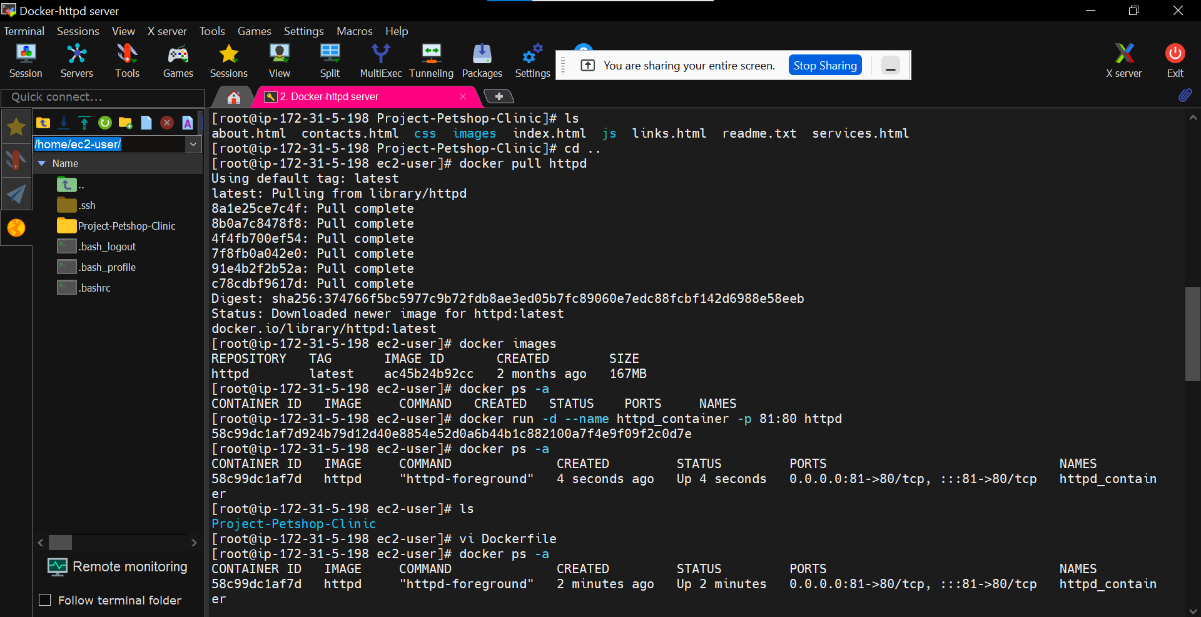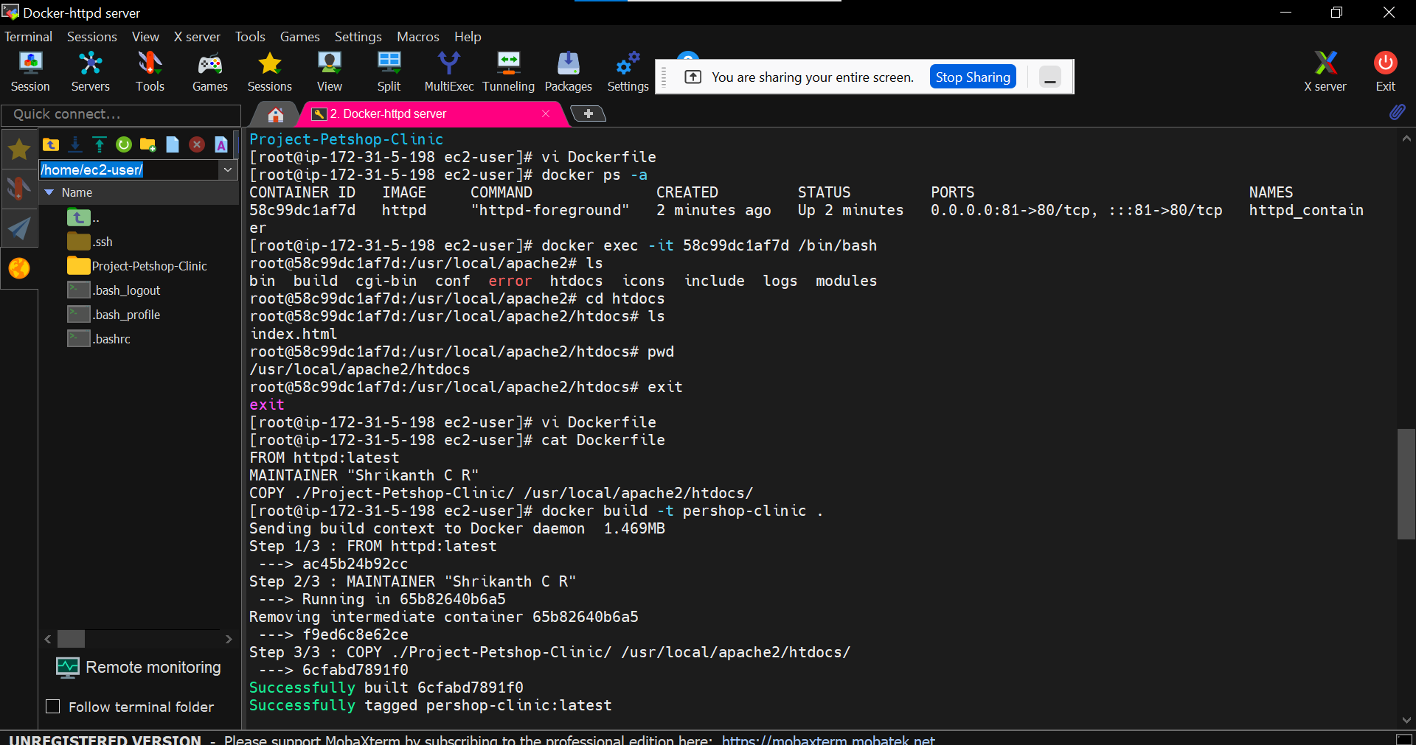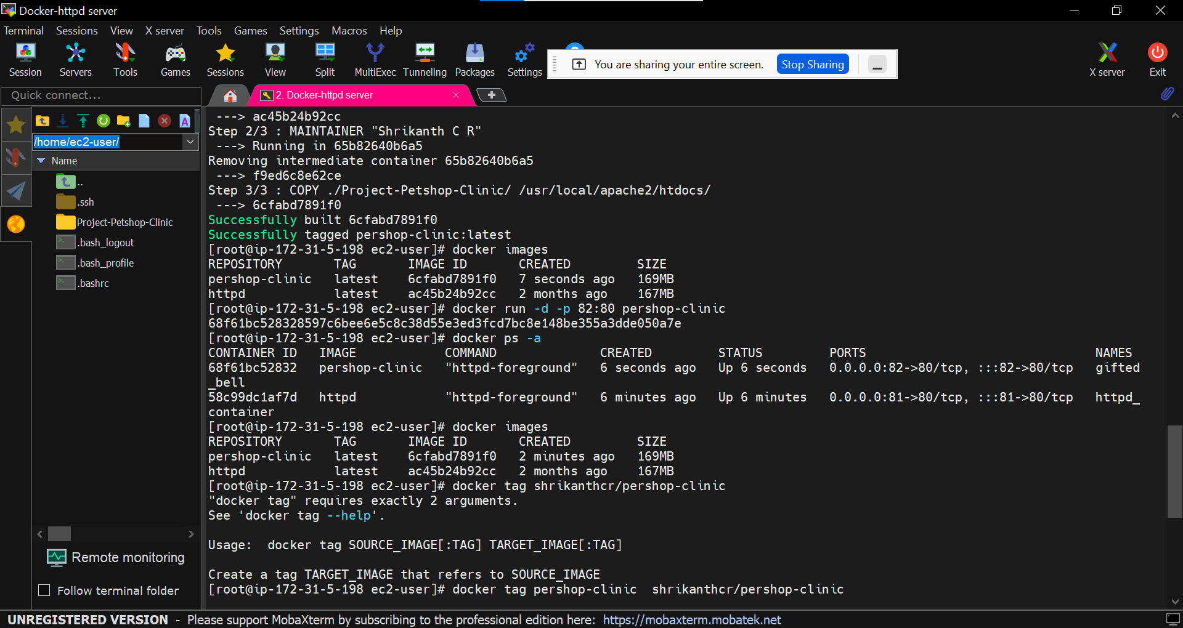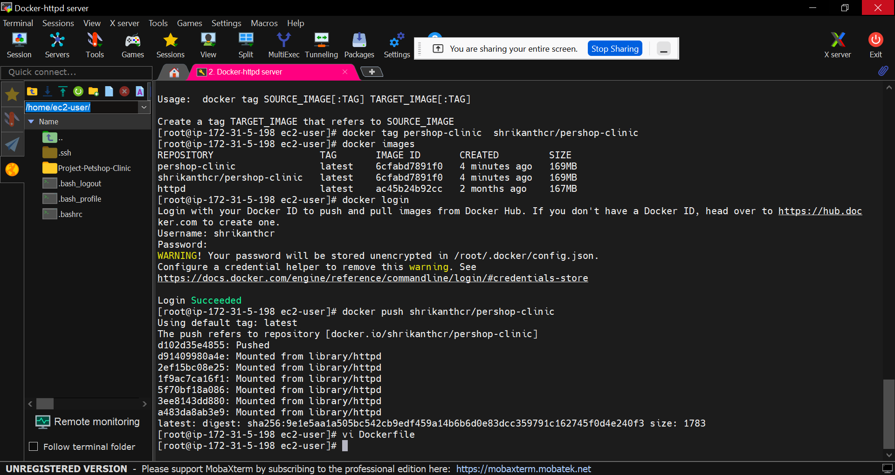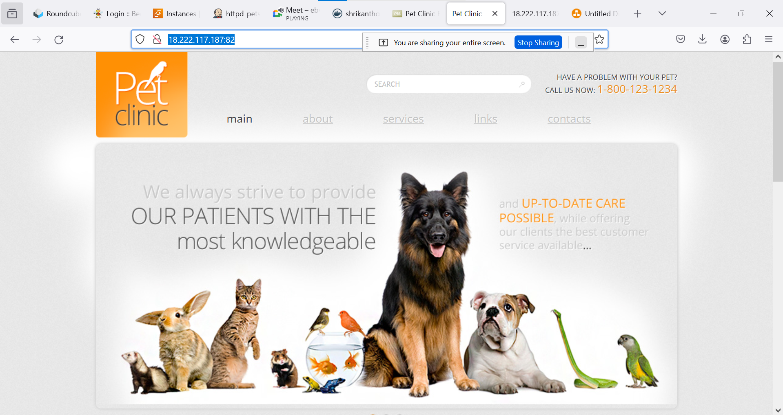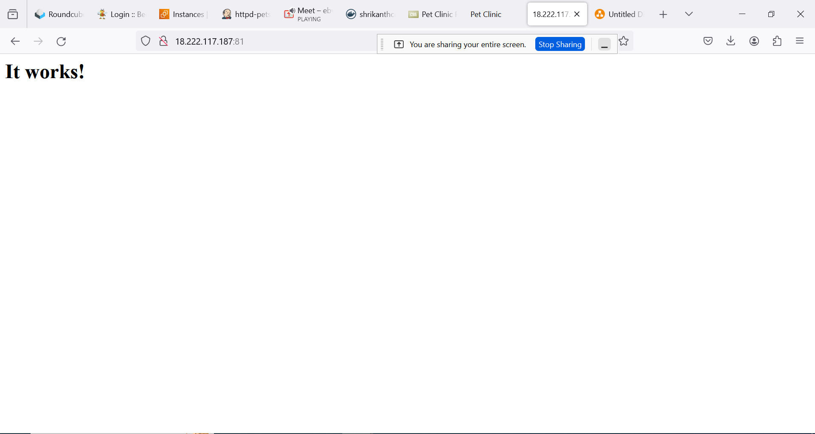

**Dockerfile:**

FROM httpd:latest

MAINTAINER "Shrikanth C R"

COPY ./Project-Petshop-Clinic/ /usr/local/apache2/htdocs/